I.) Opening the camera

- Go to the SIToolKit/LabVIEW/ExamplesXX folder.
- Go to the Open-Close folder
- Select ExOpenGlobalCam.vi and run it.
- The green light should come on when the camera is opened successfully.
- Keep camera open until you are ready to leave Labview then run ExCloseGlobalCam.vi which will close the camera and do clean up.

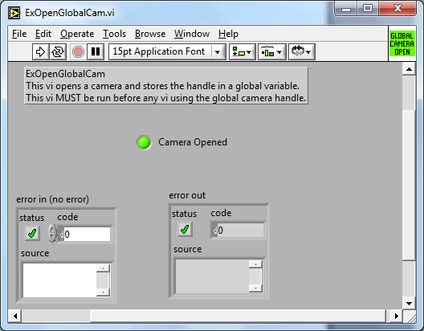

II.) Collecting data

- Go to the Q-Imaging Folder in Examples.
- This contains many examples.
- Select ExQCircBufROI.vi and fill in exposure and x and y dimension.
- Then Run example and you should see a display that is collecting data.
- Hit the “STOP” button on the panel (not the LabVIEW vi stop)

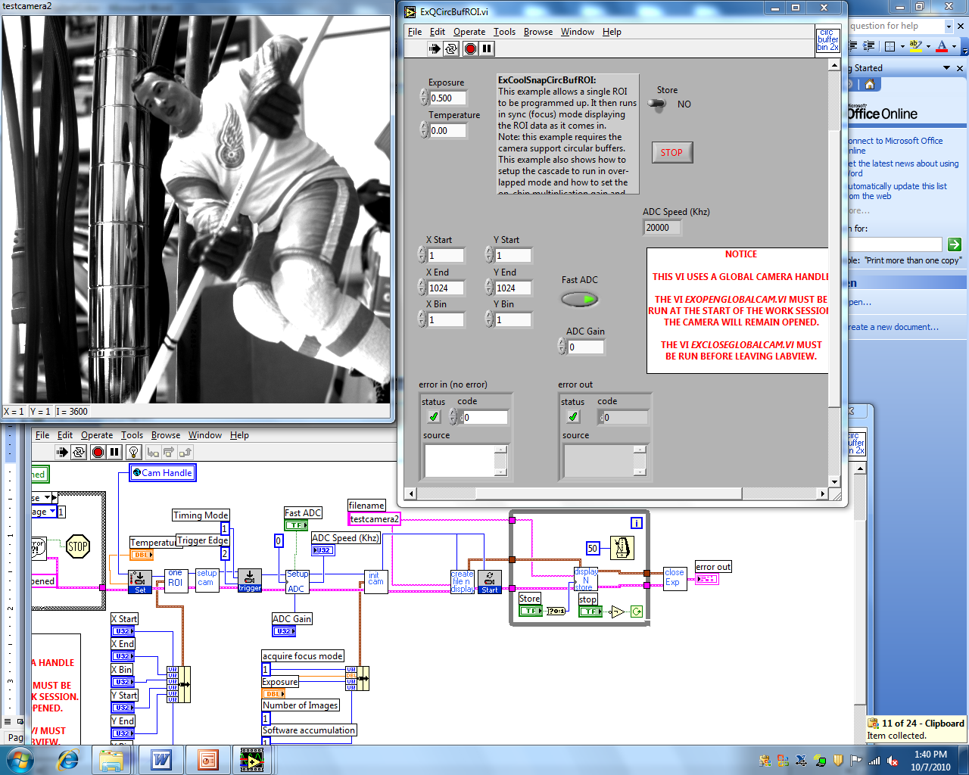

III.) Other programs that can be run.

- After the STOP button has been hit you can rerun this program or try other programs.
- ExQCircBufROI.vi shows focus mode, which continuously captures data
- ExSimpleAsyncExampleGblQ.vi shows how to capture single frames at a time.
- ExQSnapNframeSeq.vi shows how to capture a sequence of frames fast (stored in ram, then displayed when done).
IV.) Color cameras

- If you have a color camera, you can still use previous programs, but the images will be grayscale. An example of getting a color image is the data collection example ExQCircBufColor.vi.
- Fill in red, green, and blue gains. These may be different for each color camera. Some good defaults are loaded.

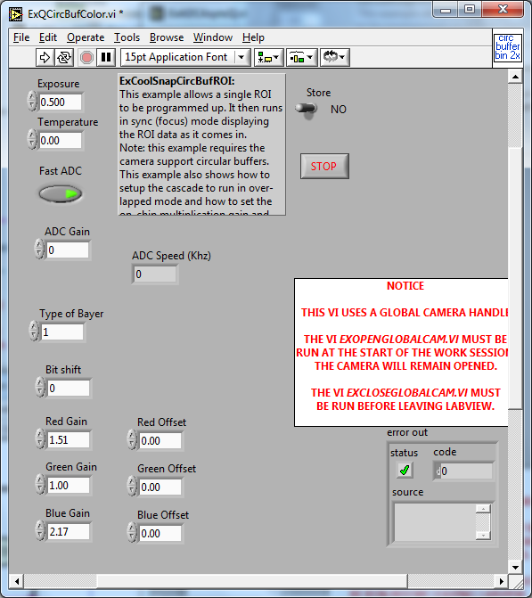
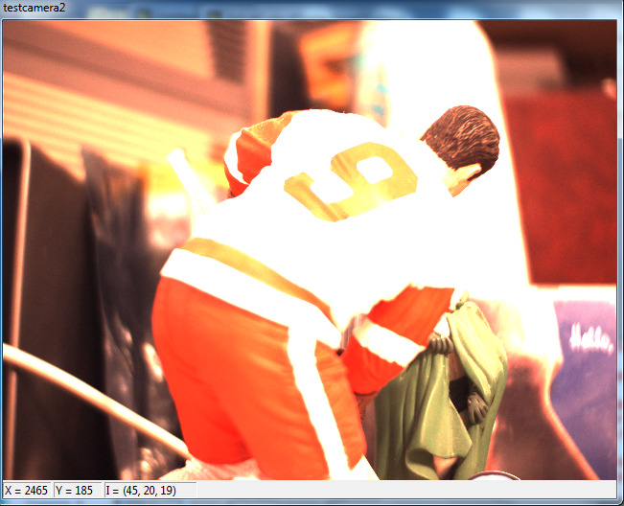
V.) SITK® for LabView Pallets

- There are 7 pallets in the user library that are supplied
- Advanced display: Full image support including overlays
- Camera: Camera setup and data collection
- Simple Display: Fast but limited feature image display.
- File: including Tif and Spe file formats.
- Image: allows pixels, rows, columns and full images to be retrieved and placed in the SITK® internal data structures.
- Math: general math operations including statistics, that are quicker than bringing data out to LabView
- General: miscellaneous functions

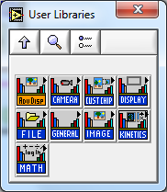
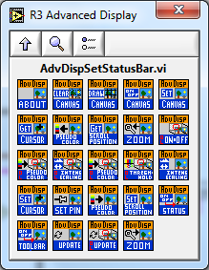

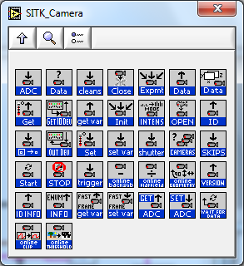
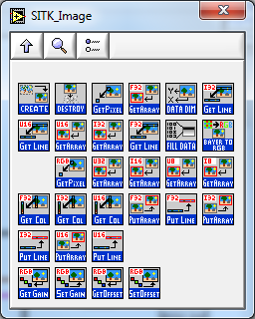

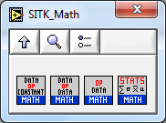

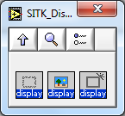

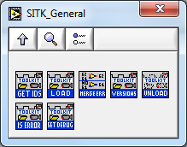

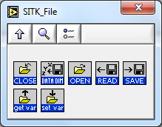
V1.) Online help

Right click on an SITK® Vi and select Help

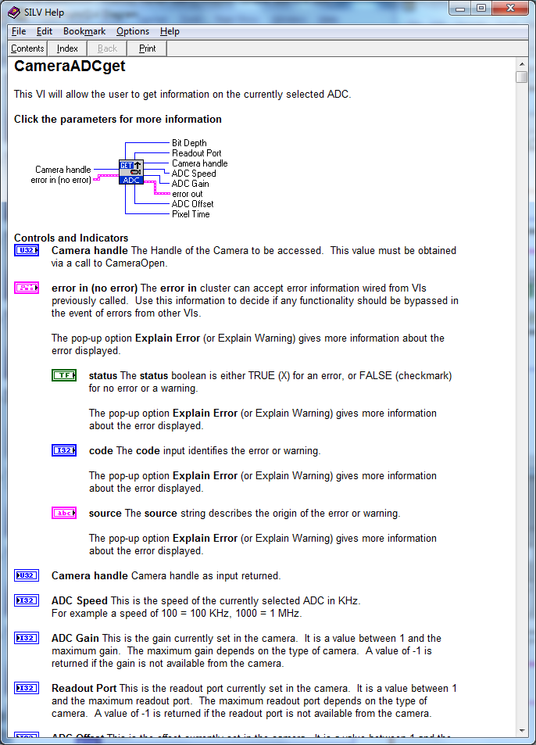

VII.) Close camera

- Before leaving Labview you should close the camera so that the software buffers are cleaned up and the camera dll’s are unloaded.
- To do this go back to the Open-Close folder and run ExCloseGlobalCam.vi

